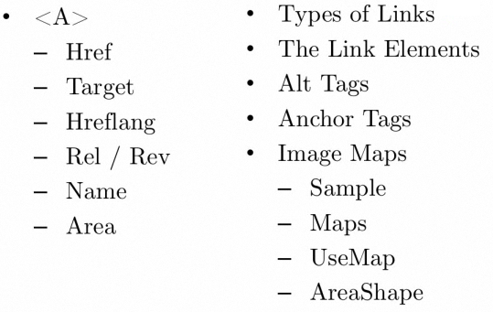

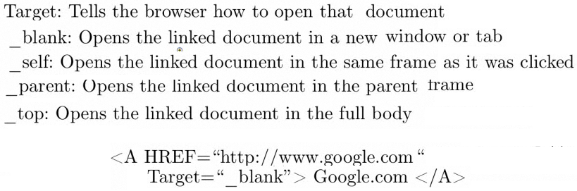

rel specifies the relationship between current document and linked document

rev specifies the relationship between linked document and current document

rel="help"

**USING LINKS TO REDIRECT INSIDE THE SAME PAGE**

Using Name, to get inside the same page (USE “#“ )

1. This is a top point of reference



1. If you click the following link, it will go to the first one, not to another page



**USING IMAGES**

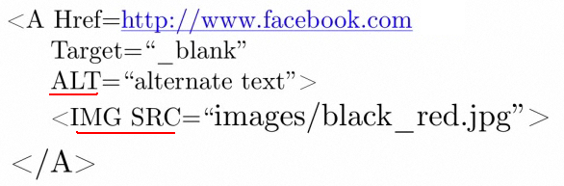

**USING MAP**

**Inside the image it draws 3 shapes and when clicking each shape it redirects**

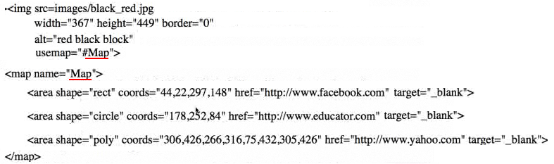

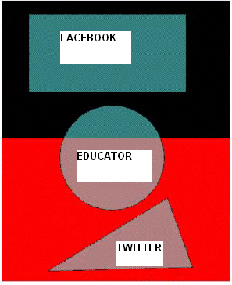

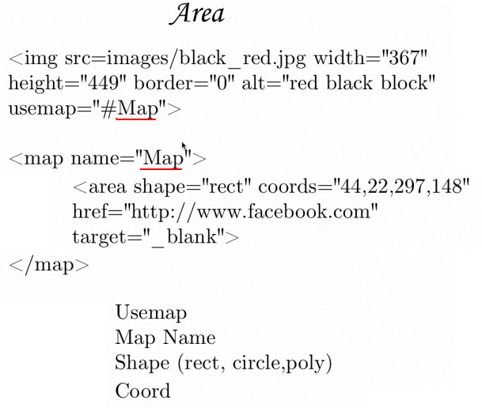

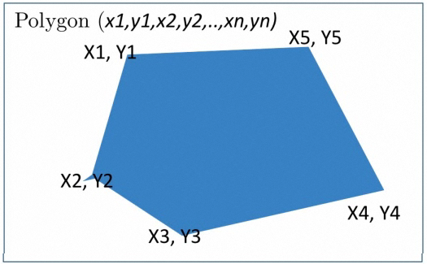

To check the coordinates for an image use **www.image-maps.com**

which is an online image map tool